**SCREENSHOTS OF THE PROJECT**

This document includes the screenshots of the project which best describes the main functionalities of the project.

1. Dashboard -

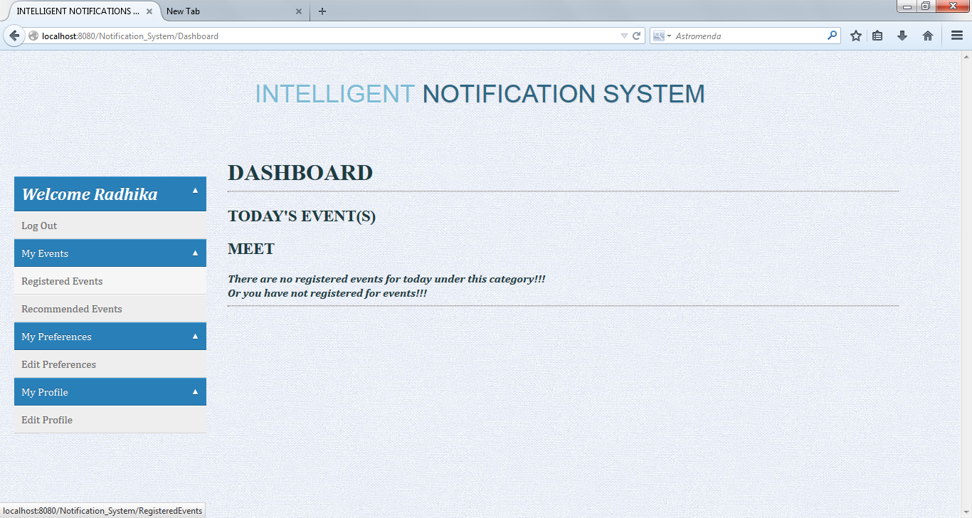

2. Edit Preferences -

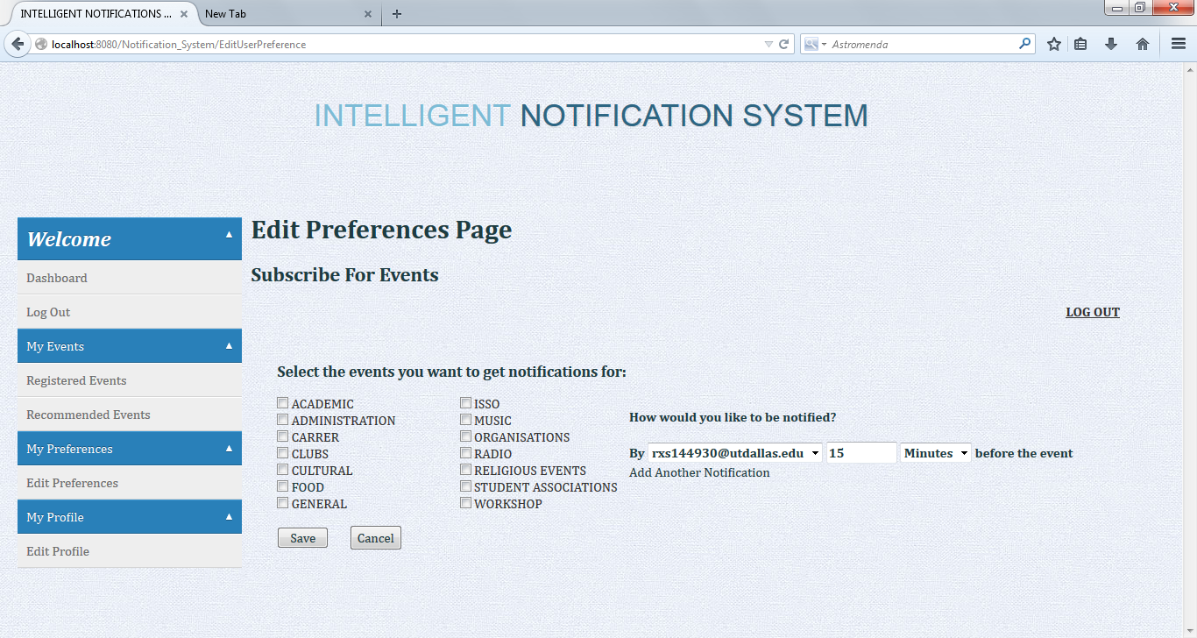

3. Register Events -

